Name of the Student | D.N SHIRSHIKA
Reg. No | 192425396
GitHub Link | https://github.com/shirshika572/Mla0403.git

SIMATS ENGINEERING

CO5 - ASSESSMENT TOOL 3

Technical Presentation

COURSE NAME: Deep Learning COURSE CODE:MLA0403
SLOT : A Faculty : Dr.Arul Raj A.M

COURSE OUTCOME COVERED

CO5: Students will be able to analyze and explain advanced generative deep learning models including Autoencoders, Deep Belief Networks, Boltzmann Machines, Deep Boltzmann Machines and Generative Adversarial Networks. They will be able to compare their architectures, explain their learning mechanisms, and apply suitable generative models to real-world problems. (BTL-3)

Course Outcome Weightage: 35% Duration: 90 minutes
Assessment Tool Weightage: 50% Mark : 25

Code of Conduct:

I _________D.N Shirshika 192425396______________________________________ (Name / Reg No) certify that this submission is my original work and that I have adhered to the guidelines specified for this assessment.
I understand that any violation of academic integrity rules will result in disciplinary action.

Signature of the student: Name of the student : DN Shirshika

Criteria | Understanding of Problem Context (2) | Application of Concepts  (3) | Problem-Solving Approach (3) | Accuracy of Solution (2) | Clarity (1) | Total (10)
Weightage | 20 % | 30% | 30% | 20 % | 10 % | 100%
Q1
Total

Signature of the Faculty: Total Marks:

PHOTO :
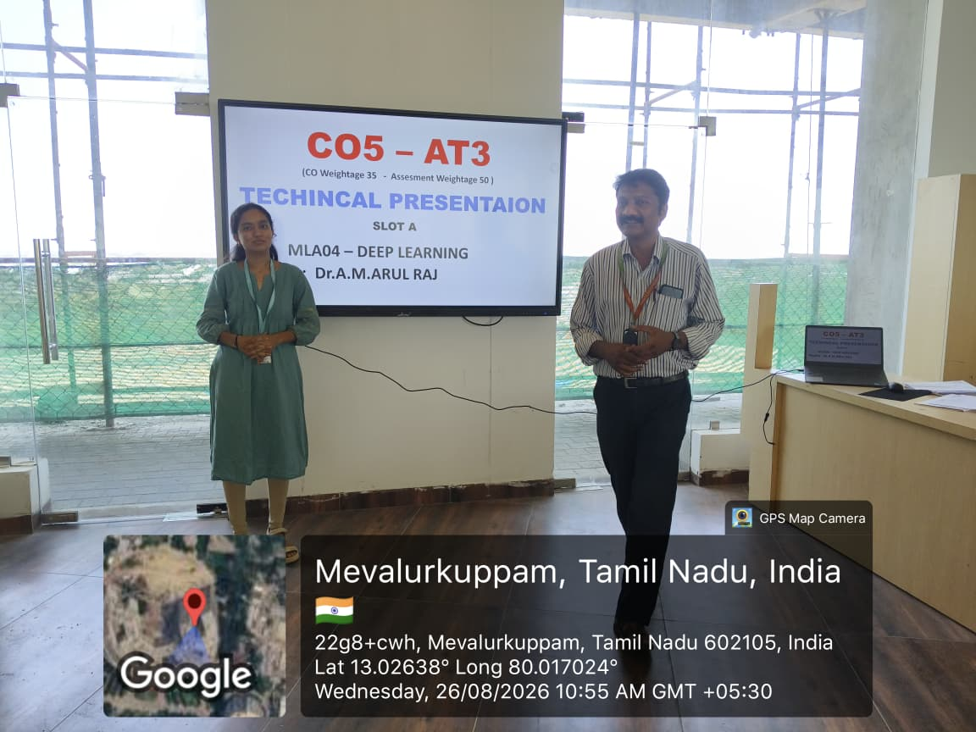

(paste your Individual Photo)

QUESTIONS:
Generative Adversarial Networks
Create a technical presentation illustrating the working of Generative Adversarial Network using the Generator and Discriminator framework. Explain the adversarial training process, loss functions, generation of synthetic data, major challenges, and practical applications. Compare GANs with Autoencoders and justify when GANs are a more suitable choice.

PRESENTATION ANSWER :

Generative Adversarial Networks (GANs)
- A deep learning technique for generating synthetic data.
- Uses two networks:
  - Generator
  - Discriminator

Slide 2 – What is a GAN?
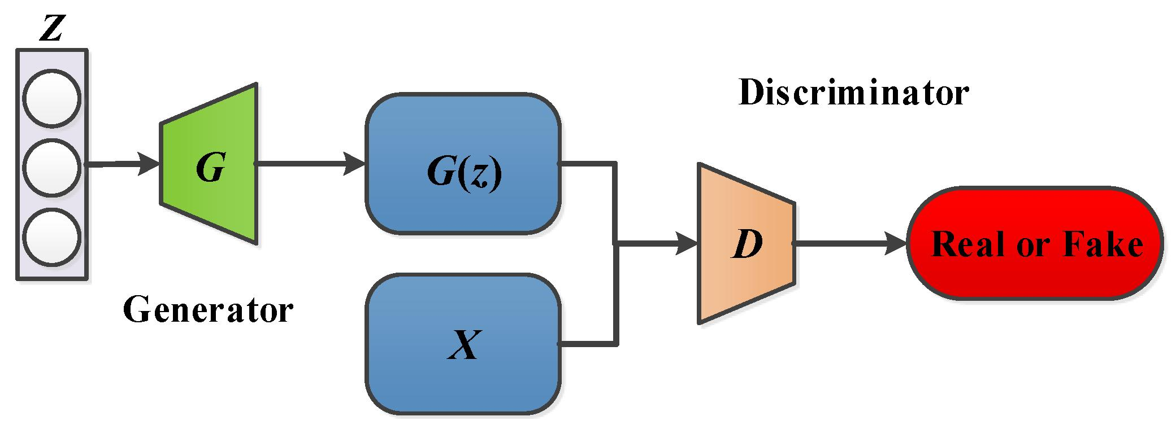
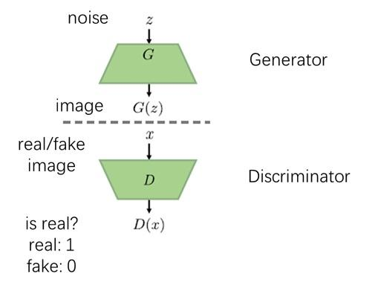

4
- Generator: Creates fake data from random noise.
- Discriminator: Checks whether data is real or fake.
- Both networks compete to improve their performance.
Simple flow:
Noise → Generator → Fake Data → Discriminator → Real / Fake

Slide 3 – How GAN Works
- Random noise is given to the Generator.
- Generator creates synthetic data.
- Discriminator receives real and fake data.
- It identifies whether the data is real or fake.
- Both networks are trained repeatedly.
- Finally, the Generator produces realistic data.

Slide 4 – Loss Functions
The loss functions guide the training process.
Discriminator Loss:
$$L_{D}=-\left[\log{D}\left(x\right)+log⁡\left(1-D\left(G\left(z\right)\right)\right)\right]$$
- Helps the Discriminator distinguish real and fake data.
Generator Loss:
$$L_{G}=-\log{D}\left(G\left(z\right)\right)$$
- Helps the Generator produce realistic data.

Slide 5 – Challenges and Applications
Challenges:
- Mode collapse
- Training instability
- Difficult convergence
- High computational requirements
Applications:
- Image generation
- Face generation
- Medical image synthesis
- Data augmentation
- Image enhancement

Slide 6 – GAN vs Autoencoder
GAN
- Generates new and realistic data.
- Uses Generator + Discriminator.
- Suitable for synthetic data generation.
Autoencoder
- Reconstructs input data.
- Uses Encoder + Decoder.
- Suitable for compression, denoising, and feature learning.
Why choose GAN?
GANs are better when the main goal is to generate realistic new data.
Conclusion
GAN = Generator creates + Discriminator evaluates → Realistic synthetic data.

RUBRICS FOR CALCULATION:
Criteria | Weightage | Level 4 Exemplary | Level 3 Proficient | Level 2 Developing | Level 1 Beginning
Understanding of Problem Context | 20 | Clearly understands the problem and accurately identifies all requirements | Good understanding with minor gaps | Basic understanding; some requirements unclear | Poor understanding or misinterpretation of the problem
Application of Concepts | 30 | Accurately applies appropriate concepts to solve complex problems | Applies relevant concepts correctly with minor errors | Applies basic concepts with limited accuracy | Fails to apply appropriate concepts
Problem-Solving Approach | 20 | Logical, well-structured, and efficient approach | Mostly logical approach with minor gaps | Basic approach with some inconsistencies | Illogical or unclear approach
Accuracy of Solution | 20 | Completely correct solution with proper justification | Mostly correct with minor errors | Partially correct solution | Incorrect or incomplete solution
Clarity | 10 | Clear, well-organized, and properly explained solution | Understandable with minor clarity issues | Limited clarity and explanation | Poorly presented and difficult to understand

